Kentucky Balance of State providers shared common struggles, barriers, and success trends in helping clients exit to positive destinations. The System Performance Measure Committee conducted a project to identify these patterns and inform Street Outreach and Emergency Shelter practices.
Kentucky Housing Corporation – 2025

Exits from Street Outreach and Emergency Shelter Trends
KY BoS System Performance Measures Committee

What was the purpose of this project?
- The qualitative data project aims to achieve a deeper understanding of our most vulnerable population, we will be focusing on individuals who are experiencing homelessness in our Street Outreach and/or Emergency Shelter projects. By engaging directly with this population, we aim to gather rich, qualitative data that goes beyond statistics to capture their stories, perspectives, and aspirations. This approach not only informs our understanding of their lived experiences but also guides the development of more targeted and effective interventions and support services. Ultimately, the project aims to empower these individuals by amplifying their voices, advocating for their needs, and contributing to informed decision-making within our community and service provision efforts.
- To gather qualitative insights – things we can’t see in HMIS – about what contributes to positive exits (to Temporary or Permanent Destinations) and negative exits (back to unsheltered or when clients disengage from services)

What we asked
- What struggles do clients commonly face? Do you see trends in certain struggles for those that are unsuccessfully housed?
- What support strategies help clients reach positive outcomes? What does your case management look like (Did you complete case plans? What tools or assessments were used if any? What type of things did you do specifically? How often were attempts made to engage with clients?) and are there any trends in the type of case management provided and the outcome of the client?
- What patterns or behaviors have you noticed in successful vs unsuccessful exits?

Why this matters
- This information adds valuable context to our System Performance Measures. It helps us identify system gaps, guide resource allocations, improve program design, and informs system-level decisions. It also gives stakeholders insight into client experiences that go far beyond what can be captured in HMIS - because your clients are more than what can be seen in the data
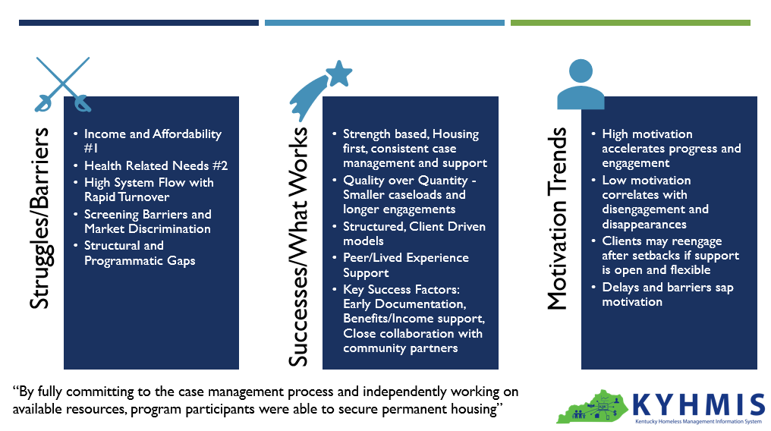

Takeaways (a snapshot)

Struggles/Barriers
- Income and Affordability is the #1 Barrier – rising rents, limited incomes, and high upfront costs make housing inaccessible for many
- Health Related Needs is the #2 Barrier – (mental health, substance use, trauma) and lack of coordinated discharges often lead to disengagement and premature exits
- High system flow with rapid turnover leads to shallow engagement and unstable exits, especially to informal supports
- Screening barriers and market discrimination (e.g., past evictions, legal histories, lack of references) prevent housing placements despite supports
- Structural and programmatic gaps – lack of IDs/contact modes, rural geographic isolation, punitive policies, inconsistent case management, and staff burnout all disrupt housing stability and service engagement

Successes – What works
Quote: “By fully committing to the case management process and independently working on available resources, program participants were able to secure permanent housing”
- Strong Case Management Practices – strength based, housing first, consistent support – resulted in better housing and income outcomes
- Smaller caseloads and longer engagement allowed for deeper work and stronger exit planning
- Structured, client driven program models and peer/lived experience support improved participation and trust
- Key success factors included: early documentation, benefits/income support and close collaboration with community partners

Motivation Trends
- Motivation is fluid and predictive: high motivation accelerates progress and engagement, while low motivation correlates with disengagement and dropout
- Clients may reengage after setbacks (“second wave” motivation) especially if support remains open and flexible
- Delays in housing navigation and system barriers can sap motivation, leading some to return to unsafe or unstable situations

Final Reflections
- Barriers are both structural and personal - success often hinges on the system’s ability to engage consistently, adapt flexibly, and support holistically.
- Trust, time, and tailored support are the backbone of meaningful housing stability.

Details

Struggles/Barriers

Income and Affordability (#1)
- Rising Rents, strict Thresholds and Multiple Deposits
- Fixed/limited incomes (makes it hard to get housing) and lack of job readiness at exit

Health (mental or physical) Related Needs (#2)
- Substance Use, untreated mental health, comorbidities (2+ Disabling Conditions – particularly women), Past Trauma
- Aggressive Behavior noted in negative exits AND returns
- Discharges from treatment facilities without coordination
- Leads to disengagement, early exits, and difficulty living independently

High System Flow/Rapid Client Turnover (in and out quickly)
- Rapid Exits are typically to informal supports and clients are less likely to sustain their housing situation

Market/Prescreening for Rentals/Rental Issues
- Lack of Rental References and housing literacy (life skills/tenant expectations/budgeting)
- Clients are increasingly “Screened out” because of past evictions or legal histories despite supports

Contact/Documentation/Accessibility
- Lack of IDs, phones or stable contact limits referrals and coordination
- Geographic and transportation barriers (especially in rural areas)
- Frequent Movement
  - Especially among men and veterans makes ongoing engagement and case management challenging
  - Made worse for SO with criminalization of unsheltered homelessness

Case Management/Program Policies
- Gaps in Engagement
- Early Exits (Auto-exiting upon Case Management Referral created loss of follow through)
- Punitive approaches and high staff turnover erode trust
  - Suggestion: separate staff for behavior issues to preserve Case Manager Relationship
- Overloaded staff limits meaningful services

Personal Factors
- Missing appointments and burnout from repeated denials
- Clients often disappear/Self Exit:
  - after long wait periods
  - if contact is lost or
  - case management is inconsistent

Successes
- Quote: “Clients who met weekly, had housing goals, and worked through steps had the best shot at success”

Case Management Approach:
- Sustained, consistent, strength-based, and housing-first case management improves housing stability.
- Fewer clients served for longer = deeper casework and better outcomes (rental housing, income, planning).
- Intensive engagement and keeping clients active (especially in SO) improve retention and housing outcomes.
- Trusting relationships between clients and case managers are critical.
- Core Case Management Strategies and Tools Mentioned:
  - Housing Plan Development
  - VI-SPDAT
  - Resume Help and Budgeting
  - Life Skills Training and Tenant Education
  - Housing Applications
  - Deposit Assistance
  - Disabling Condition Support

Program Design and Participation
  - Longer stays are associated with stronger exit plans
  - Self-driven but structured programs help clients take ownership of their progress
  - Peer support and lived experience staff enhance engagement and trust

Focus Areas for Success
  - Increased emphasis on accessing benefits and growing income
  - Early start on documentation helps prevent delays later on
  - Strong coordination with community partners supports smoother transitions and service connections

Motivation Trends
- High Motivation
  - Success is more likely
  - Housing Navigation is faster
  - More likely to participate in Case Management
- Low Motivation
  - More Disappearances
  - Disengagement
- Second Wave Motivation
  - Struggles Initially
  - Improved outcomes when reengaged after a setback
- Some disengage if housing navigation takes too long
- Others return to unsafe situations

