Instructions for Submitting your CoC APR
This process will let you see your expenditures earlier, give you a chance to request KHC Admin dollars (if available), and help you finalize your numbers with some checks and balances. All those with access to your “team” in KHC’s Web Draw system will receive an email the day your grant ends. Instructions and a due date for your annual reporting to HUD will be included in the email. This automated email will come from KHCWebDraw@kentuckyhousing.org.
If this email did not go to all parties you would like to have notified, please go to the Web Draw system for this project and “add member” to this project.
The APR form can be accessed from the Draw system by clicking on Forms and then CoC APR. This is available to you throughout your grant period. However, to get your final numbers for APR processing, you will need to wait until all your draws have been processed. KHC’s availability of Admin dollars are up to date after the 25th of the month.
Please save your completed screen before you submit, as a precaution from data loss if there is a problem with your transmission.
NOTE: This form must be completed in one setting and is saved only when you hit the SUBMIT to KHC button. Do not refresh your screen during the process. You will get a confirmation email once it has been submitted successfully. If you do not get the email, your form was not submitted.
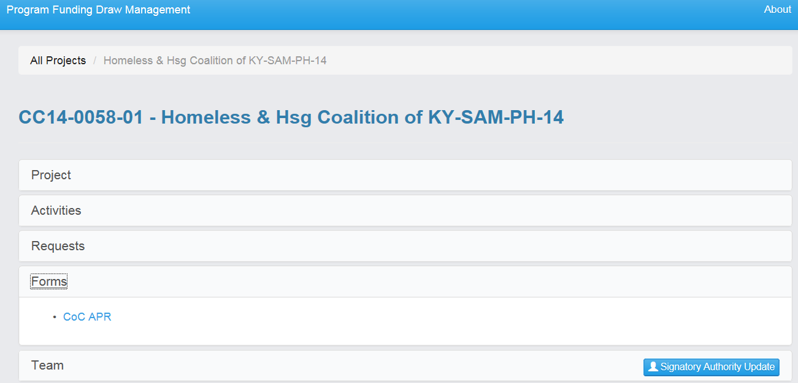
Click here to access the APR. APRAPRARPrAPR form
You will get a pop up with some information and questions to answer. Keep in mind that all the data in this example is test data. The first section that will come up will be agency and program information (below). Most of this will be prepopulated. The rest you will need to complete. Be sure to answer every question.
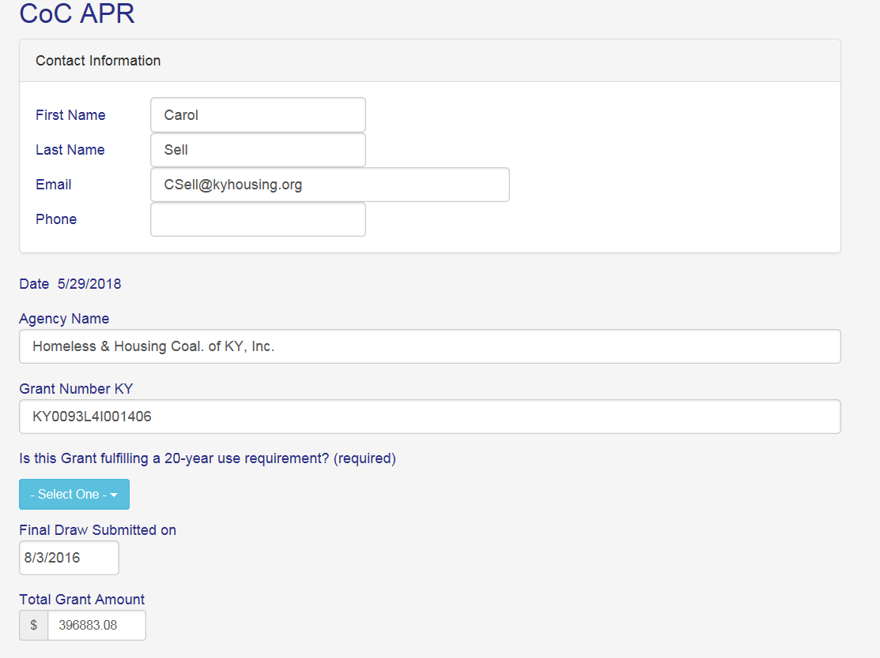
The “Use Requirement” question above is referring to a restrictive covenant question in your application (see line 6A. Funding Request, below) that basically says this grant restricts the future use of the property for a specified period of time. This usually comes when grant funds were used to build a structure.
Bed and Units Proposed vs. Actual
This next section is new and has recently been required by HUD. It compares your CoC Application proposed beds and units with the actual/available beds and units that were “occupied or available” on the four points in time in your APR. You will need your CoC Application and your HMIS APR to complete this section. Instructions are on the form for how to know what numbers should be entered for each line. *Note please read the instructions in their entirety before keying in your beds/units. There are many reasons for your average percentage to be over or under 100%. HUD has asked that you provide that reason in the Additional Comments section of the form.
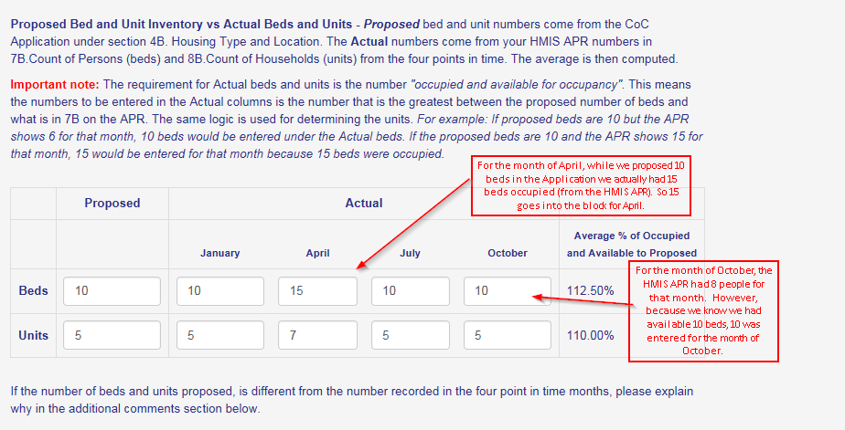
Grant Expenditures The first column on the left is broken out like your draw line items and will be automatically filled in from KHC’s draw system. That column is grayed out and cannot be changed. The next column to the right is for the agency to update, if their records show different expenditures. There will be an activity listed for every section of the budget that has expenditures.
From KHC’s web draw system
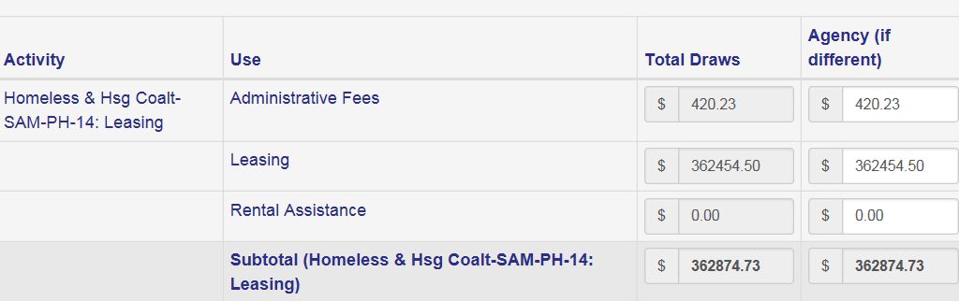
As you may recall, the ADMIN dollars from the grant are divided between KHC and the agency. The chart below should be familiar to you, as it breaks out the ADMIN expenditures. Notice there is no MATCH entered in the first column. Since we do not capture MATCH at this time, that will be blank on the KHC side. For now, you will have to enter your MATCH dollar amount to satisfy the 25% HUD match requirement.
Another advantage of this form is that you can see KHC’s Admin amount earlier in the close-out cycle. If you have Admin expenses but do not have any Admin funds remaining in your grant, and you can see that KHC has remaining ADMIN funds, contact Michelle Singer at msinger@kyhousing.org to see if those funds are already allocated. KHC will make their last Admin draw around the 25th of the month following the grant end date. However, you can contact KHC at any time to request KHC Admin.
To obtain those funds requires a budget modification so early notification is needed.
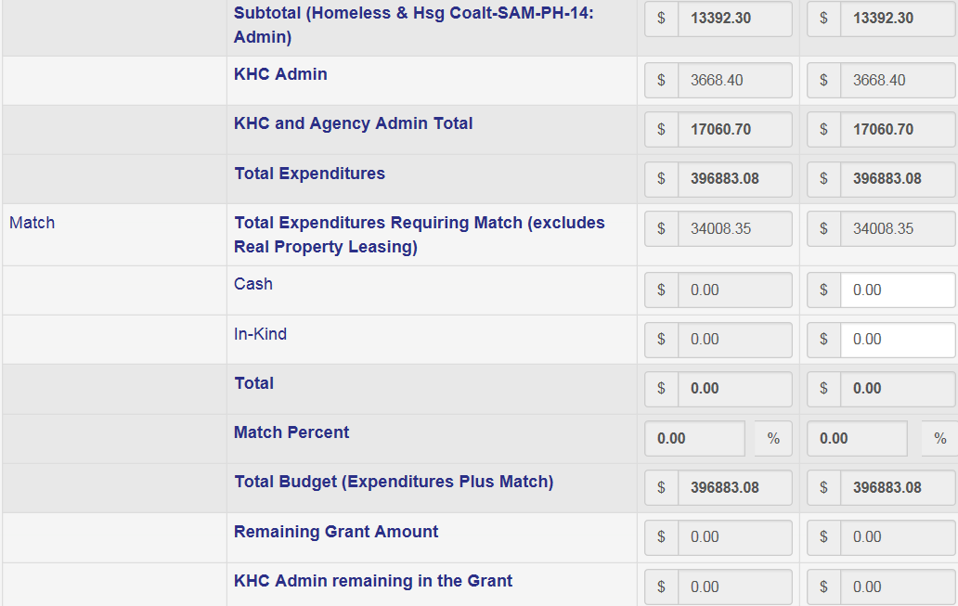
The next 3 sections are needed to complete your information to HUD. Please be sure to answer these completely. HUD will return APRs with incomplete information. Please make sure you review Q15 on your APR before completing. Please review for Data Quality prior to submission as well as include any explanation in the ‘Additional Comments’ section as well.
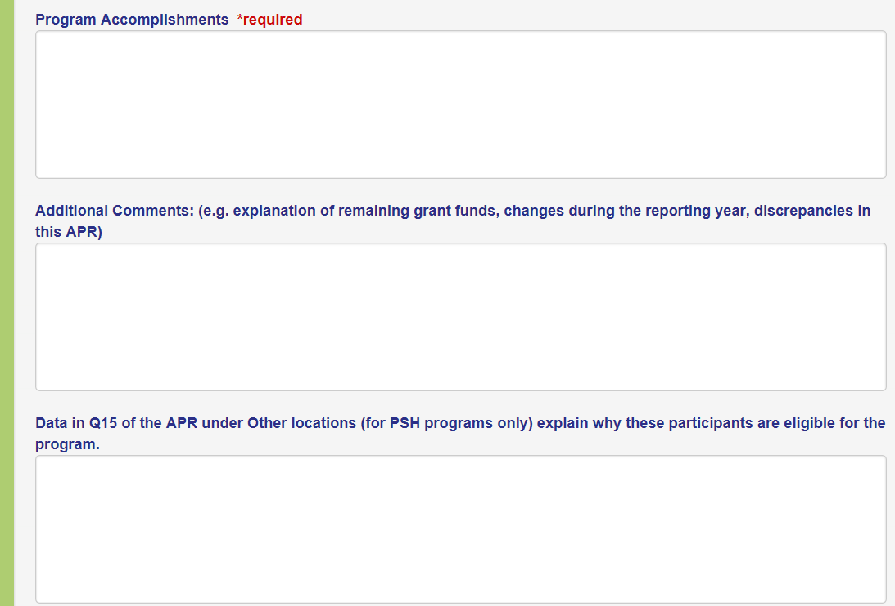
Submission and Verification The last section, below, is for you to add your “CoC APR .pdf file” and submit with this form. Please use the naming Convention “APR-agency name-your file name”. Click add and upload the .pdf file you created from your HMIS (or comparable database). You will then type your name in the submitted by block and your title. Enter the letters and/or numbers in Blue in the input box and then click on SUBMIT to KHC. You will get some questions and be asked to certify the information you have reported.
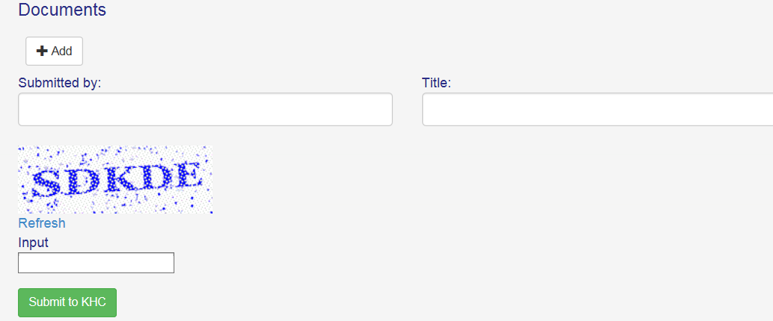
You will get a statement once you have successfully submitted. A copy of the form will be emailed to you for your records. If you do not get the screen below, your form was not submitted successfully.
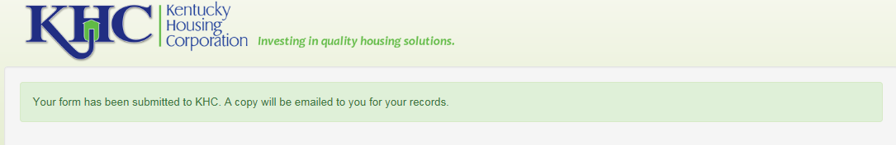

To complete the process: At this point, all that’s left is for you to send your .csv file, created from HMIS (or comparable database), to KYHMISReporting@kyhousing.org
Your APR cannot be submitted to HUD without the zipped .csv file that comes from your APR. Please review the Running an APR checking for errors and submission document located on the Help Desk for detailed guidance on submitting the data portion from HMIS.
If you have any questions or experience any difficulties, please feel free to contact the HCA Help Desk or Kayla Sexton at ksexton@kyhousing.org

