Running a CoC APR
At the top right hand side of your screen, make sure you Enter Data As and select the project you wish to run the report for
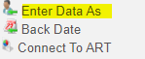

On the left-hand side click on Reports, and then under Provider Reports, click on the COC-APR
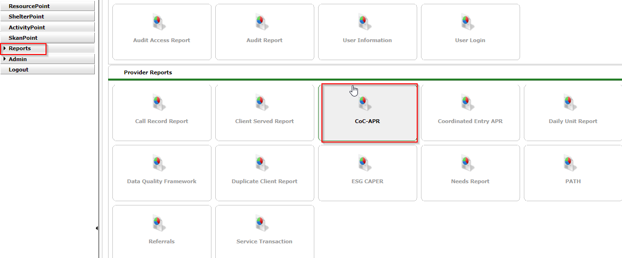

If you selected your project using Enter Data As, it should auto-populate, and you will be able to select your Program Date Range and your Entry/Exit Type and Click Build Report.
The CoC APR canned report now has Report Run History feature. This allows you to run your report as normal for each report and when you click “Build Report” it will move up into the Report Run History panel and show the status of the report.
You can also add in a Name to your report so you can easily reference it later, but it is not required.
Once the report finishes running it will show as “Completed” you can hit the refresh button or navigate away from the screen and the report will still be shown on the Report Run History panel.
To view the report, click on the magnifying glass icon and it will show you your prompts and results of your report.
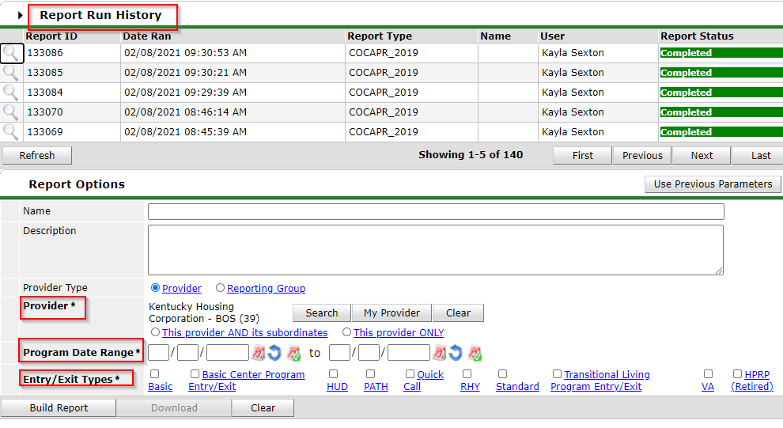

Reviewing your APR
Once your report runs, please take a few moments to review your data for Data Quality and Data Accuracy.
Paying close attention to the following highlighted fields as well as any area that has a Data not Collected section, if you have anything other than 0’s on these then you need to take a look at the data and see why that information is “missing”, “client doesn’t know”, or “refused”, you may have to provide clarification if you are unable to fix these errors.
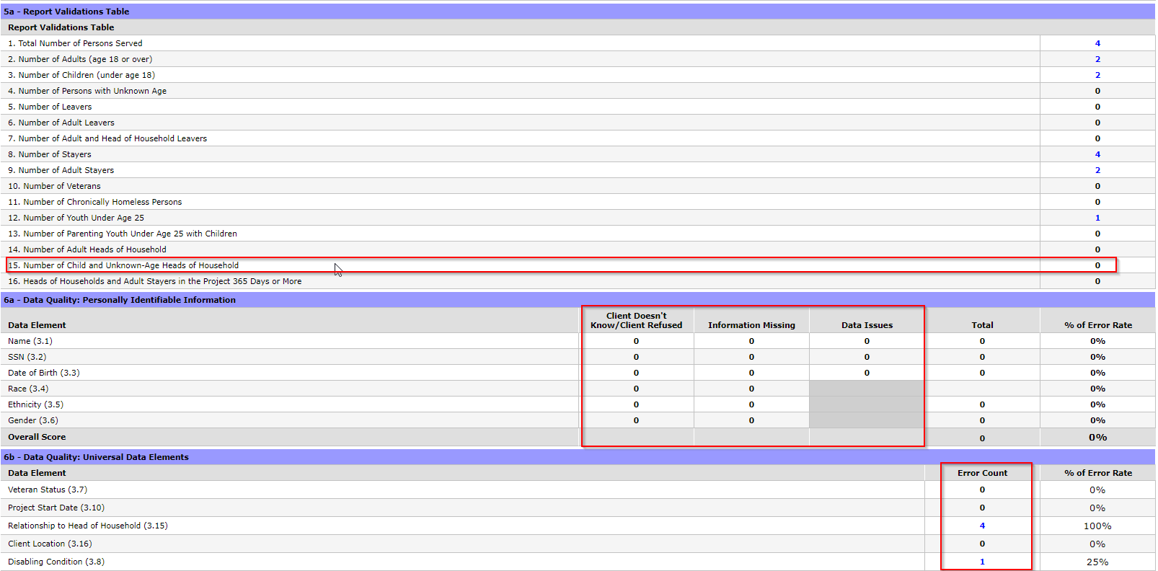
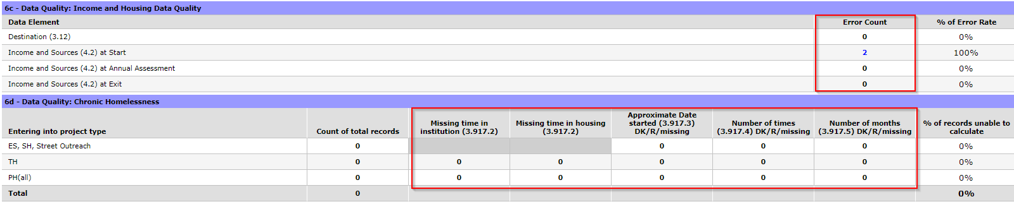
When looking at Question 15, if you have any clients that are coming from “Other Locations”, please look at those and ensure accuracy, if keyed in error please fix, if accurate we will need an explanation when you submit your APR via the web draw system.
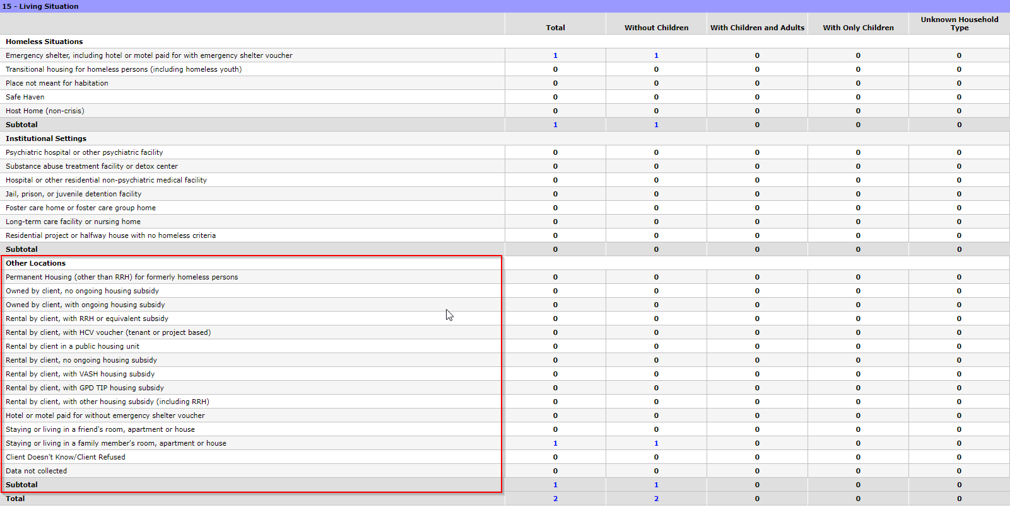
Saving as PDF

Once you have reviewed your APR for Data Quality, please save as a PDF.
Right click inside the report, go to Print. Then select Save to PDF on the “Destination” drop down. (Note: this is for web browsers using Google Chrome)

See steps below.
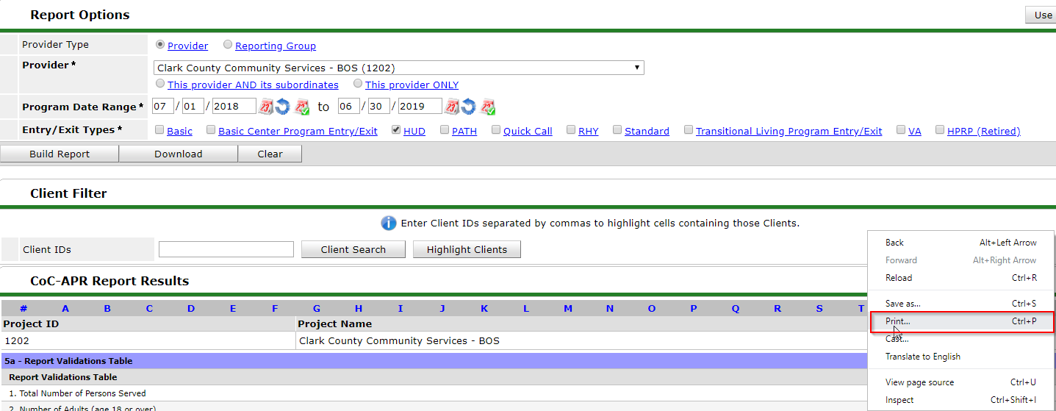
Options may vary depending on your computer, if it opens and wants to you print to an actual printer, you can change by clicking “change” or select from the drop down menu and clicking “Save as PDF”.

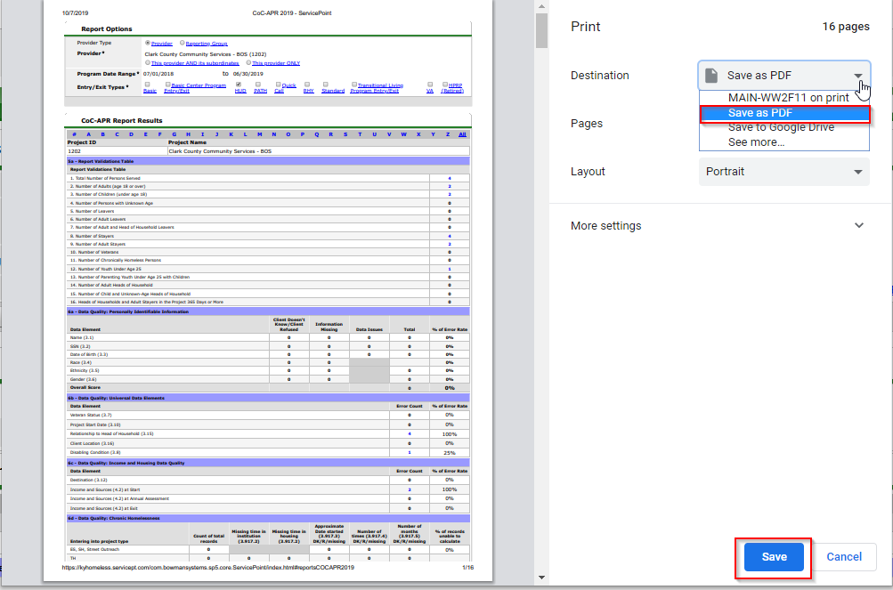
Note*
This is the preferred method we want to receive your APR, if you are having trouble, or do not see where you have the option to print to PDF, try using the google chrome browser, if that does not work, reach out to your IT contact, you may need the ability to print to PDF to be added to your computer.

Downloading the CSV zip file
Once your report has been ran, reviewed and saved as a PDF, click the Download button
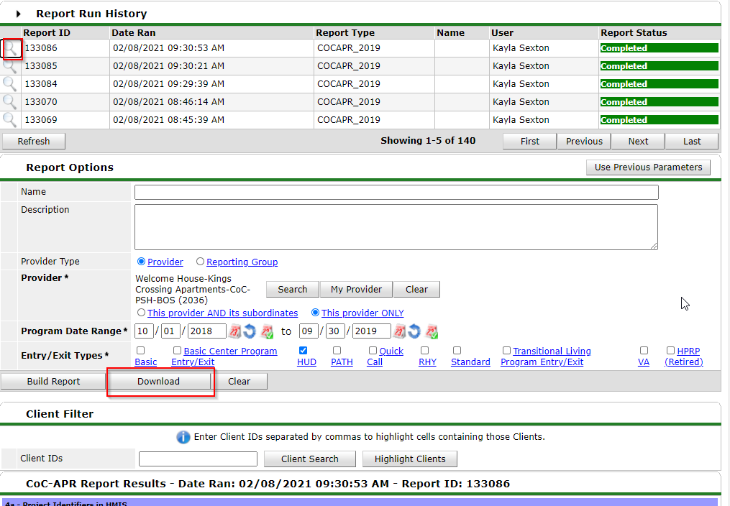
Your download will appear at the bottom, of your screen or in your downloads folder on your computer (depending on your Internet browser). Save and re-name your CSV file to the project name that you are submitting for.
Test run a report
Prior to submitting to KHC, we ask that you test run your report on Sage’s website. www.sagehmis.info (you do not need an account to use this feature)
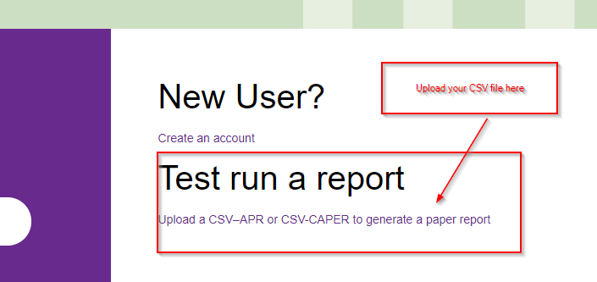
You will then select which report you are uploading whether it be a COC APR or CAPER report
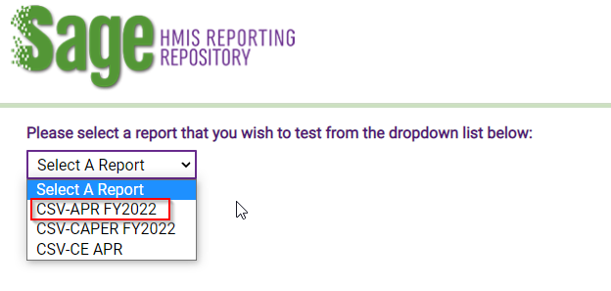
Choose your file and upload and test
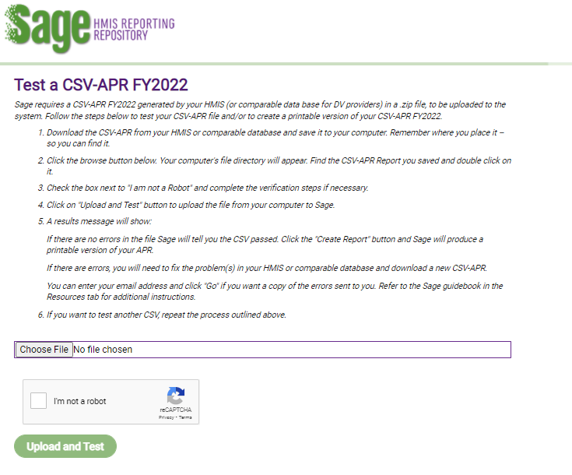

If the CSV report does not pass validation errors, please submit a Help Desk ticket.

*For instructions on how to submit your COC APR, please visit the HCA Help Desk and locate the “Instructions for submitting your CoC APR” document.

