SO (Street Outreach)

Data Quality Thresholds for KYHMIS

 |  | Data Collection Point |  |  |  | Acceptable  Level
Require For: | Field and Responses | Entry | Update | Annual | Exit | DKR | Missing
All | Number of Child and Unknown Age Head of Households | Yes |  |  |  | 0% | 0%
All | Name | Yes |  |  |  | 0% | 0%
All | Social Security Number | Yes |  |  |  | 2% | 0%
All | Date of Birth | Yes |  |  |  | 2% | 0%
All | Race | Yes |  |  |  | 1% | 0%
All | Ethnicity | Yes |  |  |  | 1% | 0%
All | Gender | Yes |  |  |  | 0% | 0%
All | Veteran Status | Yes |  |  |  | 2% | 0%
All | Relationship to Head of Household | Yes |  |  |  | 0% | 0%
All | Client Location | Yes | Yes |  |  | 0% | 0%
All | Disabling Condition | Yes |  |  |  | 2% | 0%
All | Destination |  |  |  | Yes | 20% | 0%
All | Income and Sources | Yes | Yes | Yes | Yes | 2% | 0%
All | Chronic Homelessness | Yes |  |  |  | 1% | 0%

*If a threshold is not met then a corrective action form/plan must be received with report submission.

*Note: The Street Outreach project’s data quality thresholds and completeness is only applicable after the Data of Engagement. On the Corrective Action Form agencies need to note in the explanation whether the client(s) in question have been engaged or not.

If errors are noted in the Data Quality Framework report, KHC staff will run an ESG CAPER report to check on Q9b (Number of Persons Engaged) and cross reference the clients not meeting DQ thresholds to the ones listed as engaged.

Funding Sources

The following Street Outreach (SO) programs/funding sources are currently being served in the Balance of State (BOS)

- ESG
- PATH (KHC does not currently monitor Program Specific Data Elements so it is the responsibility of each PATH agency to review and monitor these for Data Completeness/Data Accuracy at the agency level)
- ESG CV
- RHY (For RHY funded projects, refer to the RHY DQ plan on the Help Desk)
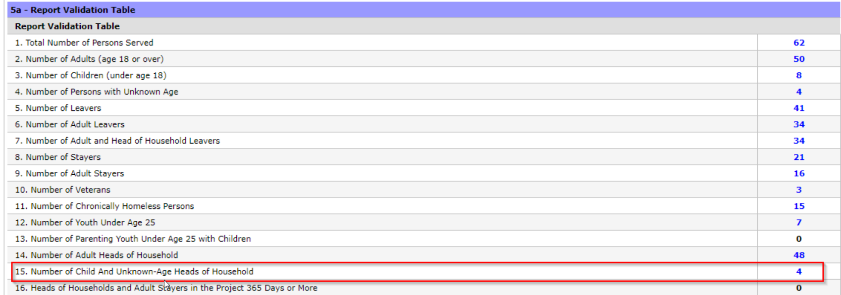

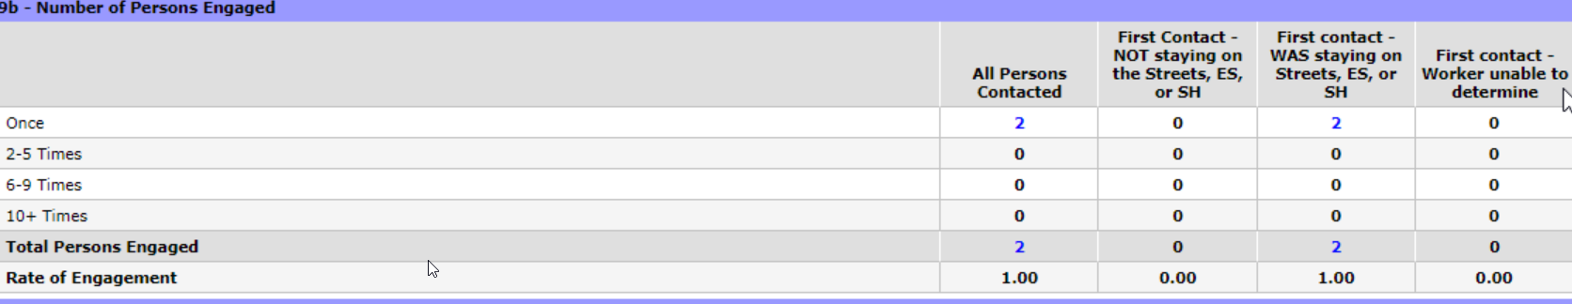

As shown in the example above, there are 4 clients showing as not meeting the “Number of Child and Unknown Age Head of Households” threshold and 2 clients showing on Q9b “Number of Persons Engaged.” Therefore, it can be determined by cross referencing the 4 clients with errors with the 2 clients listed as engaged (Q9b) * – that this adheres to the Data Quality thresholds as noted above

*Note: Since the 4 clients with errors were not listed as engaged, all thresholds were met.

As shown in the example below, Street Outreach projects should list all the client IDs showing as an error on the Corrective Action Form. This will allow the agency and KHC staff to distinguish between the errors that are showing are Engaged or Not Engaged clients. This method will also show that the agency has verified they have checked each client’s Engaged or Not Engaged status in HMIS.

Corrective Action Form Ex:

Client ID: | 123456; 789101 |  | Threshold Error: | Child Head of Household
Explanation: | Engaged
Corrective Action: | Working on fixing errors

Client ID: | 111213; 141516 |  | Threshold Error: | Child Head of Household
Explanation: | Not Engaged
Corrective Action: | Cannot correct errors as the clients are not engaged

