RHY (Runaway Homeless Youth)

Data Quality Thresholds for KYHMIS

 |  | Data Collection Point |  |  |  | Acceptable  Level
Require For: | Field and Responses | Entry | Update | Annual | Exit | DKR | Missing
All | Name | Yes |  |  |  | 0% | 0%
All | Social Security Number | Yes |  |  |  | 2% | 0%
All | Date of Birth | Yes |  |  |  | 2% | 0%
All | Race | Yes |  |  |  | 1% | 0%
All | Ethnicity | Yes |  |  |  | 1% | 0%
All | Gender | Yes |  |  |  | 0% | 0%
All | Veteran Status | Yes |  |  |  | 2% | 0%
All | Relationship to Head of Household | Yes |  |  |  | 0% | 0%
All | Client Location | Yes | Yes |  |  | 0% | 0%
All | Disabling Condition | Yes |  |  |  | 2% | 0%
All | Destination |  |  |  | Yes | 3% | 0%
All | Chronic Homelessness | Yes |  |  |  | 1% | 0%

The following RHY Program Component/Funding Source are currently being served in the Balance of State (BOS)
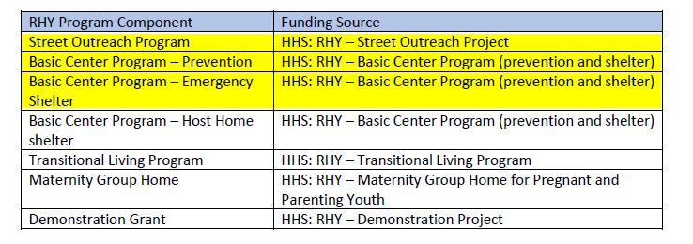

Therefore, the following Basic Client Information must be collected on all RHY funded clients, which can be monitored by using the Data Quality Framework report from KYHMIS.

*If a threshold is not met then a corrective action form/plan must be received with report submission.

*Note: The Street Outreach project’s data quality thresholds and completeness is only applicable after the Data of Engagement. Agencies only need to provide a Corrective Action plan/form for clients with a Date of Engagement for these projects.

Basic Client Information Section of DQF report
3.01 Name (Q2 of DQF report)
3.02 Social Security Number (Q2 of DQF report)
3.03 Date of Birth (Q2 of DQF report)
3.04 Race (Q2 of DQF report)
3.05 Ethnicity (Q2 of DQF report)
3.06 Gender (Q2 of DQF report)
3.07 Veteran Status (Q3 of DQF report)
3.08 Disabling Condition (Q3 of DQF report)
3.10 Project Start Date (Q3 of DQF report)
3.12 Destination (Q4 of DQF report)
3.15 Relationship to Head of Household (Q3 of DQF report)
3.16 Client Location (Q3 of DQF report)
3.917 Prior Living Situation (Q5 of DQF report)

Program Specific Data Elements

Within HMIS, different funding sources and projects require collection of different program specific information. The table below shows all Program Specific Data Elements in which the Elements highlighted in yellow are required for RHY projects currently being served in the KY Balance of State (BOS).

Therefore, it is important that each RHY funded agency check for data completeness for all Program Specific Data Elements on a regular basis to stay in compliance with their RHY funded program.

All RHY funded projects must collect the following Program Specific Data Elements.

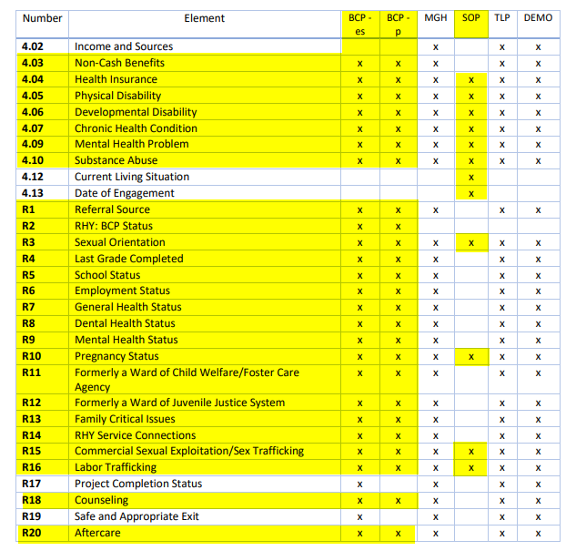

KHC does not currently have a report to monitor these Program Specific Data Elements, so it is the responsibility of each agency to review and monitor these for data completeness/data accuracy at the agency level.

