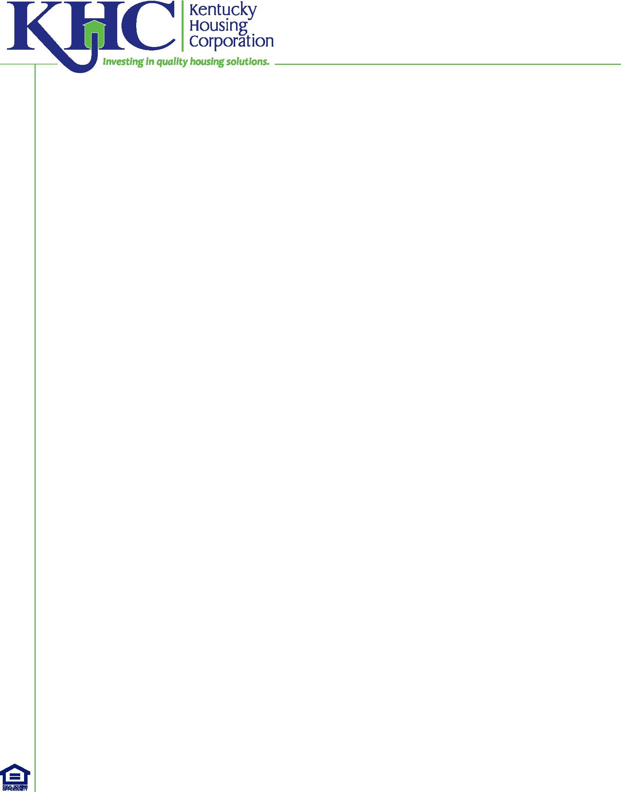
HOME TBRA - Acknowledgement Waiver Annual Re-Inspection
In use during COVID-19 applicable to TBRA provided from
April 10, 2020 to December 31, 2020.

Waiver/Suspension of Annual Re-Inspection of Occupied HOME TBRA units
Agency Name:  Agency Representative Name:  Agency Representative Email: | Date:
Tenant:

Address of Unit:

Mailing Address:

--------------------------------------------------------------------------------------------------------------------------------------------------------------------

To facilitate the provision of assistance to individuals and households during the COVID-19 pandemic and to protect the health of both inspectors and tenants by observing physical distancing recommendations to limit the spread of COVID-19, our agency has suspended the Annual HQS Re-Inspections of HOME TBRA units required to occur from April 10, 2020 through December 31, 2020.

This agency has developed written procedures to minimize the risk that tenants are in housing that does not meet HQS, and the agency will conduct a physical inspection within 120 days following the end of the December 31, 2020 waiver/suspension period.

Signature of Agency Representative:

KHC CVD19 HCA-214 (4/21/20)

