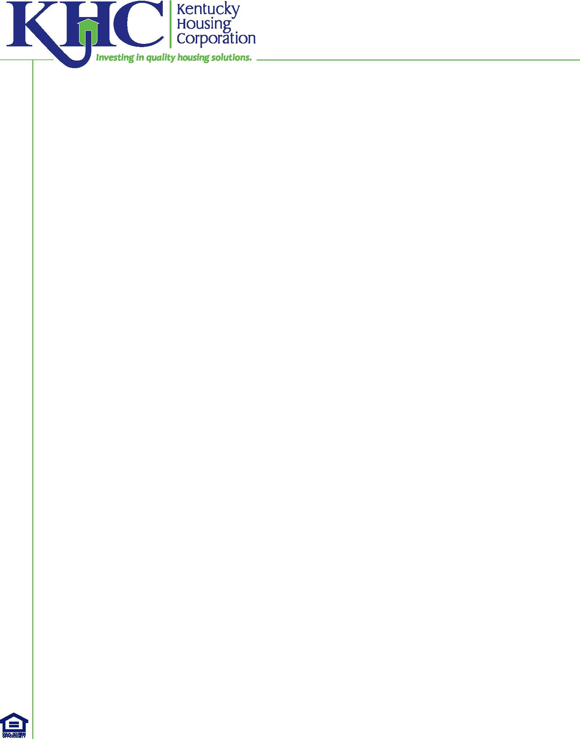
HOME TBRA - Acknowledgement Waiver Initial HQS Inspection
In use during COVID-19 applicable to TBRA provided from
April 10, 2020 to December 31, 2020.

Waiver/Suspension of the Initial Housing Quality Standards (HQS) Physical Inspection
Agency Name:  Agency Representative Name:  Agency Representative Email: | Date:
Tenant:

Address of Unit:

Mailing Address:

--------------------------------------------------------------------------------------------------------------------------------------------------------------------
To facilitate the provision of assistance to individuals and households during the COVID-19 pandemic our agency certifies the following:

The tenant household being assisted with HOME TBRA is experiencing financial hardship; and

The unit being assisted was built:

Post 1978

Pre 1978. Lead Safe Housing requirements of 24 CFR 34 subpart M cannot be waived, consequently units built pre-1978 must undergo a visual evaluation and paint repair in accordance with 24 CFR 35 subpart M; Use KHC form HCA 203 to document the visual evaluation.

The Initial Housing Quality Standards (HQS) Physical Inspection is suspended until December 31, 2020. This agency has developed written procedures to minimize the risk that tenants are in housing that does not meet HQS, and the agency will conduct a physical inspection within 120 days following the end of the December 31, 2020 waiver/suspension period.

Signature of Agency Representative:

KHC CVD19 HCA-213 (4/21/20)

