COMMON ISSUES SEEN WHEN REVIEWING THE APR
Reminders
- The Sub-grantee’s CoC APR is due to KHC 45 days after the end of the grant period
- Wait on the final draws to be processed before completing web draw forms, otherwise the financials will not match up with what your submitting on your form
- Attach a PDF of your HMIS/Data CoC APR along with your program and financial information form (web draw form)
- Print a copy and keep for your records.
- Email the CSV file to KYHMISReporting@kyhousing.org
- Submit an HCA Help Desk ticket if you have any questions or need any assistance.

Bed & Unit Utilization

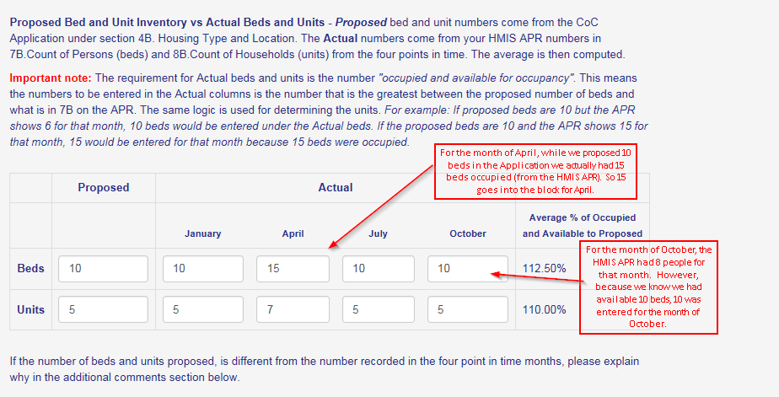
- It is important to always read the instructions, which clarifies some common mistakes
- your beds/units should reflect the “greatest between the proposed number of beds and what is in 7B /8B of your HMIS/Data APR

Program Accomplishments

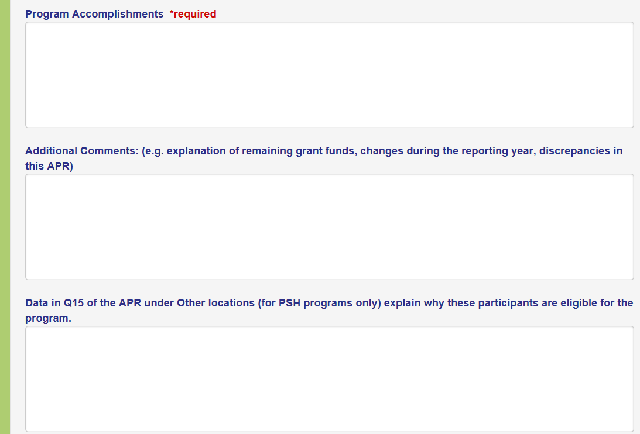
- Program Accomplishments- is looking for information that cannot be found by looking at your CoC APR:
  - Success stories- people served that may have obtained employment or enrolled in college through the help of the project or; perhaps they were able to get enrolled in Insurance or obtained benefits (SNAP, SSI, etc.)
- Additional Comments- use this section to explain why your bed/unit inventory is different than what was proposed, or explain why you have remaining grant funds or any other type of discrepancies in the APR etc.
- Data in Q15- This section wants to know why you have people in “Other Locations” use this section to clarify or explain those client’s eligibility for your project
*Note: Do not use Safe Haven as a prior living situation for the Balance of State, (there are no Safe Havens in the BOS).
Data Quality Checks

- Review the data
- Check for errors
- Look for areas where it says
  - Client Doesn’t Know/Client Refused or (DK/R/Missing)
  - Missing Information
  - Data Issues
  - Error Count
- Any Data Quality issues will need to be fixed prior to submission to KHC, if unable to fix, submit a HCA Help Desk ticket so that KHC staff can assist, if still unable to fix error the agency will need to provide an explanation under the Additional Comments section

Helpful Documents

There are several helpful documents on the HCA Helpdesk under the Kentucky Homeless Management Information System (KYHMIS) that have detailed instructions for submitting APR’s including…
- Updates to the FY2019 APR 10/1/2019
- Instructions for submitting your CoC APR
- Running an APR, checking for errors and submission

- There are also documents with detailed instructions for the ESG CAPER including…
- Updates to the FY2019 APR 10/1/2019
- Instructions for submitting your ESG CAPER
- Running an ESG CAPER, checking for errors and submission

- Additional helpful documents include…
- Downloading and Saving the CSV zip file
- Saving as PDF

