Airport Noise Worksheet

Use this worksheet to identify information needed to evaluate a site’s exposure to aircraft noise.

Name and Location of Project: 503 Brevard Street, Franklin-Habitat for Humanity of Simpson County
Name of Airport: Portland Municipal
Person completing worksheet: Curtis Stauffer Date: 6/5/2019

- Determine if the proposed site/project is within 15 miles of a civil or military airport.

No. Attach a scaled map identifying the location of the proposed project site and the location of any airports. Further use of this worksheet is not required.
Yes. Attach a scaled map identifying the location of the proposed project site and the location of any airports. Continue.
X

- Determine the number of operations at the airport by:
- Go to: http://www.gcr1.com/5010web/advancedsearch.cfm
- Find your airport using the Search function
- Open the report under “Print 5010”
- Complete section 3 below by using Operations data found in the report (see yellow arrow in the example below)

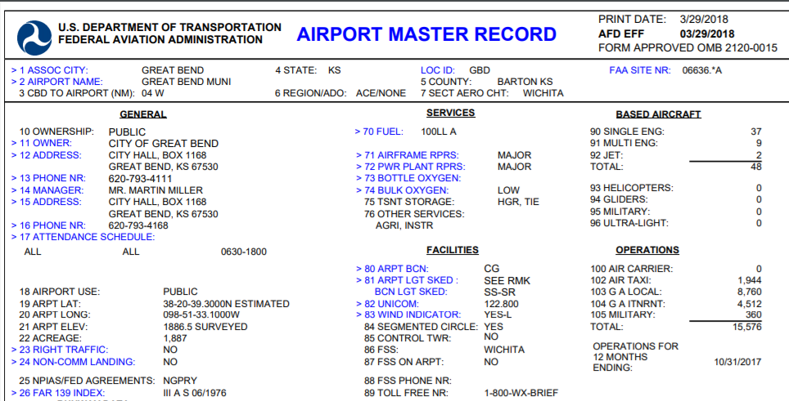

- Determine if the annual number of operations for air carriers (#100), air taxis (#102), military (#105), and general aviation (#103 plus #104) exceeds the thresholds provided below.

#100 Annual air carrier operations 0_. Is this 9,000 or more? Yes __ No_X
#102 Annual air taxi operations 225. Is this 18,000 or more? Yes __ No X
#105 Annual military operations _60. Is this 18,000 or more? Yes __ No X
#103+#104 Annual general aviation operations 5185 Is this 72,000 or more? Yes__ No X

- If you answer “No” on each of the questions above, it is assumed the noise attributed to the airplanes will not extend beyond the boundaries of the airport. Maintain the documentation in your Environmental Review Record (ERR). You are finished with the evaluation of airport noise for this airport.
If you have marked any question in #3 with “Yes,” continue to 5.

- Contact the airport manager, (see blue arrow above) and ask them if the airport has noise contour maps. Are contour maps available?

Yes. Locate your project on the noise contour map. If there are no roads or railroads that are being considered for noise, utilize the information from the contour map to determine if the site is acceptable. If roads or railroads are being considered, input the information obtained from the airport noise contours, along with the road and railroad information, into HUD online noise calculation tool at http://www.hud.gov/offices/cpd/environment/dnlcalculator.cfm.

No. Construct the approximate DNL contours by using the guidance on page 52 and 53 of the HUD Noise Guidebook. You will need to obtain the following information from the airport:
- The number of nighttime jet operations (10pm to 7 am).
- The number of daytime jet operations (7 am to 10 pm).
- The flight paths of the major runways.
- Any available information about expected changes in airport traffic (e.g., will the number of operations increase or decrease in the next 10 to 15 years?).

Contact your HUD Environmental Officer if you need assistance.

