|  |
| --- |
| Kentucky Housing Corporation |
| How to use EVA |
| Used for Data Quality and System Wide Monitoring |

|  |
| --- |
|  |

How to Use EVA

HMIS Steps (do these first)

1. In HMIS, on the Reports Tab, Select Hashed HMIS CSV and start a New Export

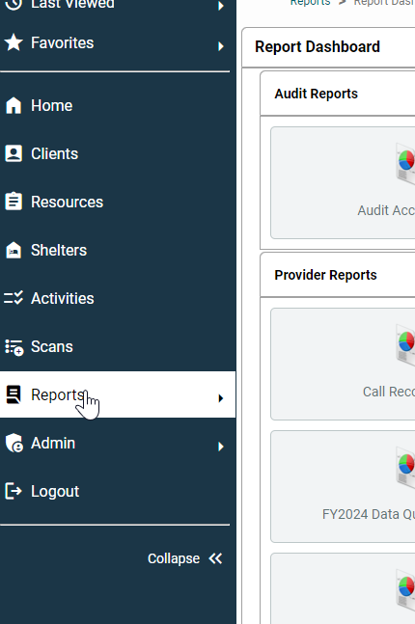

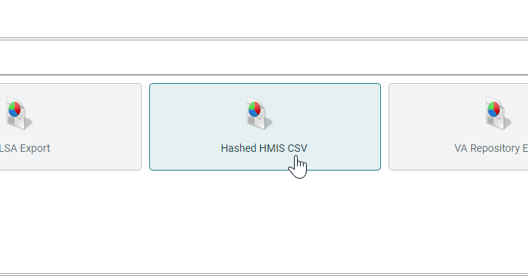

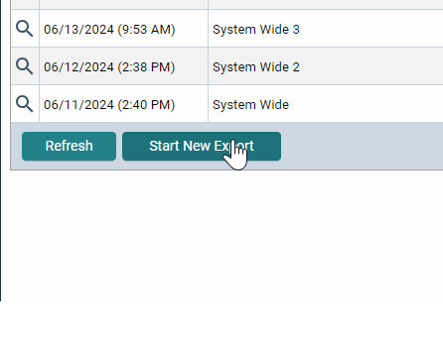

1. A Name is required to run the report, feel free to name it whatever you want that makes most sense for you to know what the export is.
2. Run the rest like a regular CAPER or APR
   1. Select an Entry Data Type (Most likely HUD)
   2. Search for your project
   3. Enter a report start and end date. For Data Quality the dates used are always (The Month Data Quality is being done/15th/one year before – The Month Data Quality is being done/15th/Current year. For example- 7/15/2023-7/15/2024 if Data Quality is being done in July)
3. When you are done filling it out, select “Run Export.”

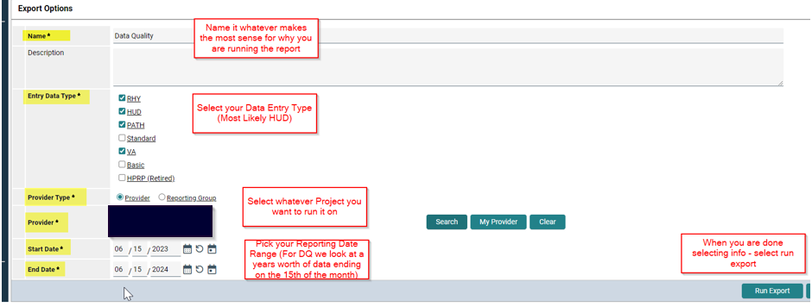

1. When the status of your Export shows “Completed,” just like with other reports in HMIS, select the Magnifying glass to view more information.

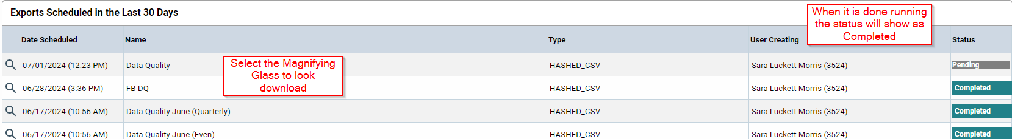

1. From here you will select “Download Results” and it will download as a CSV/Zip File into your Downloads folder

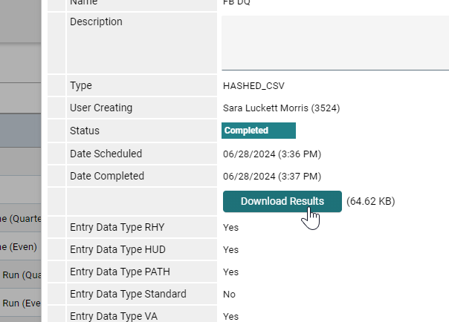

EVA Steps (Only do this once finished with the steps in HMIS)

1. Open Eva at this link <https://hmis.abtsites.com/eva/> and “Click here to Get Started.”

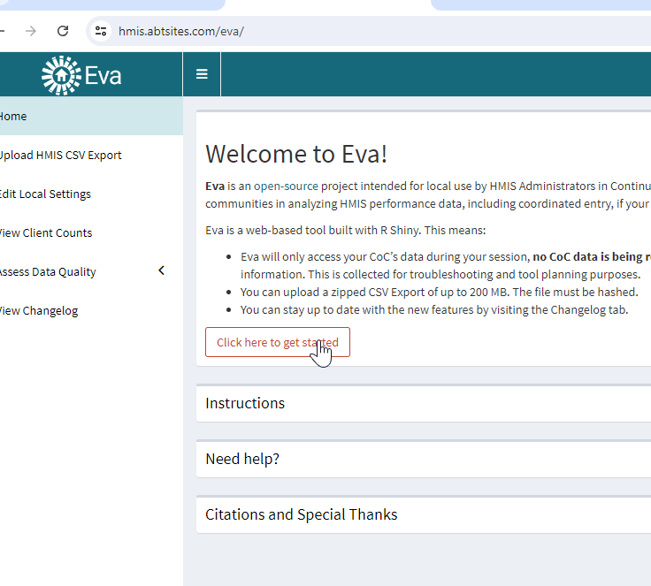

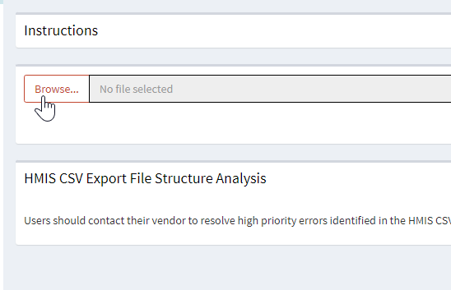

1. From there you can go to your Downloads and select the CSV you just downloaded from HMIS

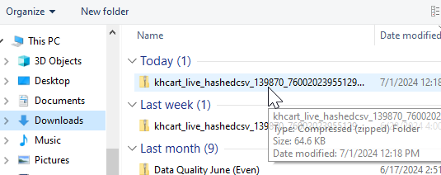

1. It will load and eventually you should get this notification:

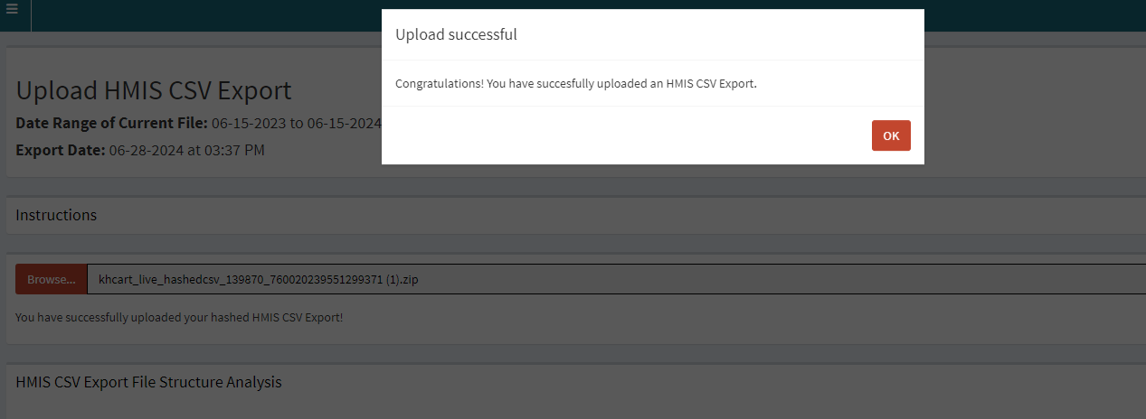

** Note: If, for some reason, you get a notification of the Upload being *Unsuccessful* please submit an HCA Help Desk ticket and someone on the HMIS Team will assist you

1. Once successful, you can navigate to these side tabs:
   1. Edit Local Settings (this is where you can add information on what constitutes a long stayer – we use the default of 90 days)
   2. View Client Counts
   3. Assess Data Quality
      1. Check PDDEs
      2. System Level
      3. Organization Level

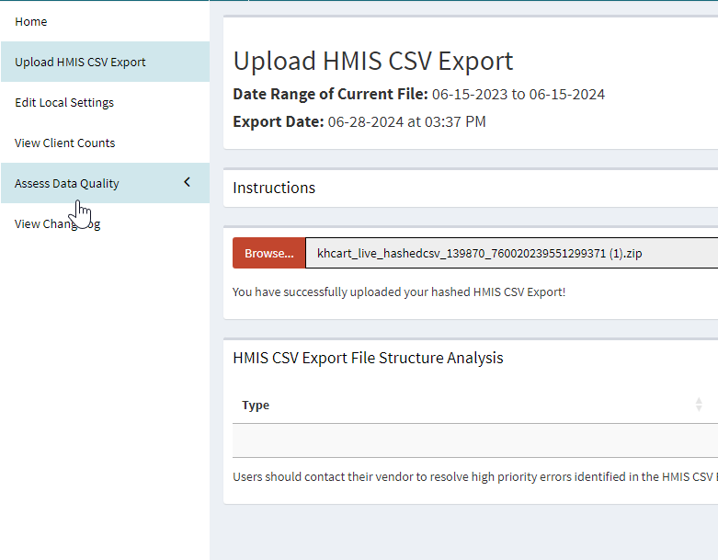

1. When looking at it on a project basis, it is suggested to look at the organization level tab under “Assess Data Quality”:

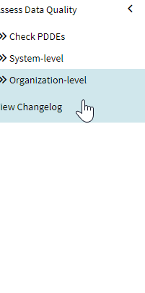

1. That should bring you to this:

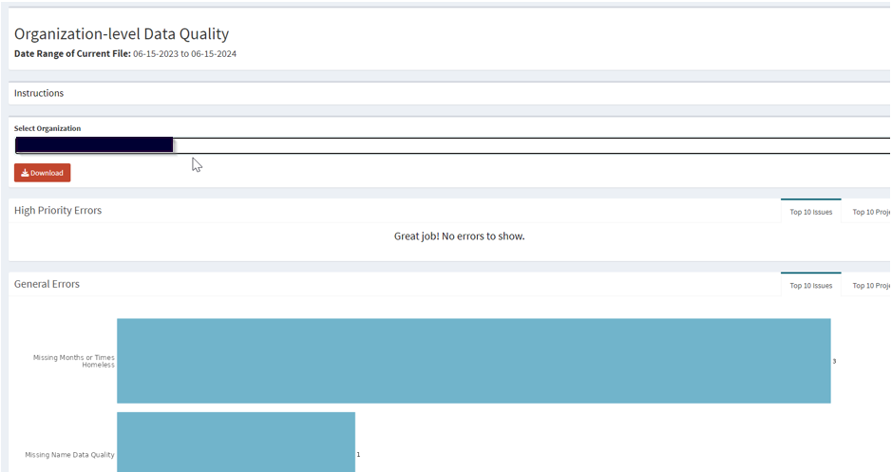

1. From here, you can look at the graphs of your High Priority, General Errors, Warnings, Summary, and Guidance.
2. To Navigate to the Excel Sheet that we send you for Data Quality and System Wide Monitoring Purposes, select Download.

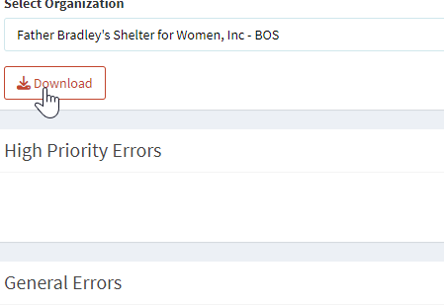

1. It will then download the excel workbook with Export information, Guidance, High Priority, and Errors.

** Note: Some of the Warnings and errors are not included in the Data Quality Review – only System Wide Monitoring:

* Duplicate Entries
* Invalid Move in Date
* Missing Year Separated
* Missing War(s)
* Missing Discharge Status
* Missing Military Branch
* Missing Year Entered Service
* Missing HP Screening or Threshold Score
* Missing Percent AMI
* Enrollment Crosses Operating Start
* Enrollment Crossing Participating Start
* Missing Previously Unsheltered, ES, SH
* Missing VAMC Station Number
* Incorrect Year Separated
* Long Stayers (Local Settings)
* Days since Most Recent CLS Exceeds Local Settings
* Overlap with an Emergency Shelter (E/E) project.
* Overlap with a Rapid Rehousing project.
* Overlap with a Transitional Housing project.
* Long Stayers (Outliers)
* Days Referral Active Exceeds Local Settings
* Overlap with a Permanent Supportive Housing project.