Contents
System Overview 2
Quick Start 2
Access 2
Link to the Program Funding Draw Management System 2
Register 3
Create a User Account 3
Lost Password 4
Project Requests 5
Request a Project 5
Access Pending Request 5
Team Management 6
Add People to the Team (Signatory Authority is required) 6
How to Submit an Updated Signatory Form 7
Delete a Person 7
Change a Person’s Role 8
Approving a Request 8
Deny a Request 8
Project Draw Requests 9
Create a New Draw Request 9
Modify a Draw Request 9

System Overview

Kentucky Housing Corporation (KHC) created an electronic program funding draw management system that will be used to request funds from programs administered by the corporation.

It is recommended that you use Internet Explorer 9 or above, the latest version of Firefox or Chrome when completing your requests using a desktop or laptop. The draw management system can also be accessed from mobile devices such as tablets and smartphones.

Quick Start

- Register/Create an account.
- Request access to a project.
- After project access is approved create and submit the draw request.

Access

Link to the Program Funding Draw Management System

Register

Create a User Account
All users are required to create an account.

- Click Register.
- Enter your Email Address.
- Enter your Email Address again to confirm it was entered correctly.
Note: The email address entered will be your login ID.
- Enter a Password.
- Enter the Password again to confirm it was entered correctly.
- Enter your First Name.
- Enter your Last Name.
- Enter your Company Name.
- Enter your Title.
- Click ‘Terms and Conditions’.
- Read the policy.
- Check the box if you agree with the policy.
- Click 'Register'.

Lost Password
Kentucky Housing Corporation staff does not have access to passwords. To reset your password access the Program Funding Draw Management System and click the link ‘Password Help.’

- Enter the email address used to register the account.
- Click ‘Request New Password’.
- You will receive an email with instructions to reset your password.

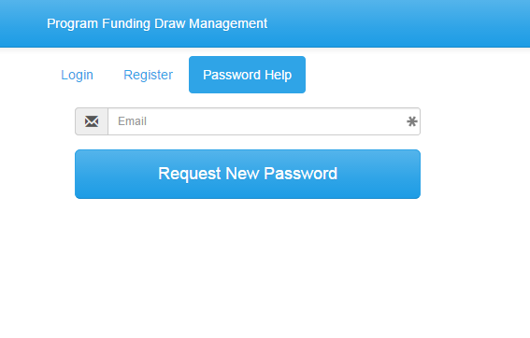

Project Requests

A draw request cannot be created until a signatory authority submits a project request and they are approved by KHC staff. Other user types can be approved once the signatory authority has been approved through the team management.

Request a Project
- Click ‘Projects’
  - From the Projects dropdown Click ‘Request’ (to add projects)
  - Click ‘+ Add project’ (if this is your first request)
- Enter the Project Number assigned by KHC.
- Click ‘Request Role’
- Select a role from the drop down.
  - View Only - Will have access to the draw and all information but cannot create or submit a draw.
  - Preparer – Can create and prepare the draw but cannot submit the draw.
  - Signatory Authority (SA) – Can create a draw, prepare the draw and submit the draw. Signatory Authority must be approved by KHC staff and be listed on the signatory authorization form submitted to KHC.
- Click ‘Request’

Access Pending Request
- Click ‘Request’ from the dropdown.
  - You may request addition projects.
  - Delete a request.

Team Management
Team Management is used by the signatory authority to add addition people to a project so they may assist in the draw process.

Add People to the Team (Signatory Authority is required)
- Click ‘Project’
- Click the ‘Project Number’
- Click ‘Team’
- Click ‘Invite’
- Enter the email address of the person.
- Select the Role from the dropdown.
  - View Only - Will have access to the draw and all information but cannot create or submit a draw.
  - Preparer – Can create and prepare the draw but cannot submit the draw.
  - Signatory Authority (SA) – Can create a draw, prepare the draw and submit the draw. Signatory Authority must be approved by KHC staff and be listed on the signatory authorization form submitted to KHC.
- Click ‘Send’ and an email will be sent notifying them they have access to the project.

How to Submit an Updated Signatory Form
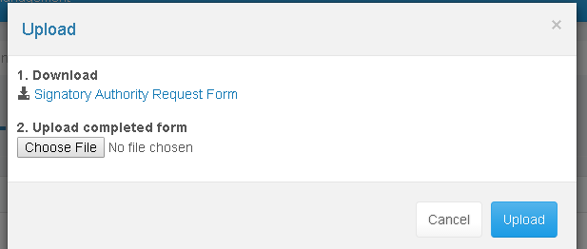
- Open the project.
- Click the ‘Signatory Authority Update’ button on the Team section.
- A copy of the form can be found by clicking the link 1. Download.
- Complete the form and save a scanned copy to your computer.
- Click ‘Choose File’
- Locate and select the completed Signatory Form.
- Click ‘Open’
- Click ‘Upload’
- The file is submitted to KHC for review.

Delete a Person
- Click the Project Number.
- Click ‘Team’
- Click the Person’s Name.
- Click ‘Delete’
- Click ‘OK’ to permanently the person from the project team.

Change a Person’s Role
- Click the Project Number.
- Click ‘Team’
- Click the Person’s Name.
- Select the Role from the dropdown.
  - View Only - will have access to the draw and all information but cannot create or submit a draw.
  - Preparer – Can create and prepare the draw but cannot submit the draw.
  - Signatory Authority (SA) – Can create a draw, prepare the draw and submit the draw. Signatory Authority must be approved by KHC staff and be listed on the signatory authorization form submitted to KHC..
- Click ‘Done’

Approving a Request
- Click the Approvable Request
- Click ‘Action’
- Click the ‘Approve’
- An email will automatically be sent to the requestor.

Deny a Request
- Click the Approvable Request
- Click ‘Action’
- Click the ‘Deny’

Project Draw Requests

This the area of the system that is used to create and submit a draw request to KHC.

Create a New Draw Request
- Click ‘Projects’
- Click the ‘Project Number’
Note: This is project number provided by KHC (e.g. AA15-0999-01)
- Click ‘Activities’
- Click ‘Draw’ for the activity to request funds.
- Complete the following required fields for all request types:
  - Is this your final project draw? Select Yes or No from the dropdown.
  - Has your “Bank account changed?” Select Yes or No from the dropdown.
  - Is there a scheduled inspection for this draw?
Note: Only enter ‘Yes’ if your project requires an inspection from KHC staff and a date has been determined.
  - Enter the inspection date.
- In the ‘Total Request’ enter the full amount of the funds being requested.
- Enter the amount for each use/ line item funds are being requested.
- Complete the “Other Non-KHC Funding” section if required for your program.
- Attach all required/supporting documentation as listed or requested.
  - Click ‘+ Add’
  - Click ‘Choose File’
  - Locate file.
  - Click file.
  - Click ‘Open’
  - Click ‘Upload’
- After all information is entered click:
  - ‘Save for later’ if you are entering the request on behalf of a signatory authority.
  - ‘Save and Submit to SA’ if the draw is complete and to send an automated email message to the Signatory Authority the draw is complete.
  - ‘Save and Submit to KHC’ if the draw is complete and you have signatory authority review the certification and click the correct response.
- Any errors will be displayed and must be corrected.

Modify a Draw Request
Only draws that have not been submitted can be edited.
- Click ‘Projects’
- Click the ‘Project Number’
- Click ‘Requests’
- Click ‘Request ID’ for the activity to modify.

