Available Now: HOPWA Oversight Training Online Modules
This series of three self-paced online modules helps HOPWA grantees and their project sponsors improve the management and oversight of their HOPWA activities. HOPWA grantees and project sponsors will learn how to develop a framework and plan for HOPWA oversight, how to monitor eligible activities, and how to monitor financial management. The modules include practical tips, interactive elements, and downloadable handouts. This training is a companion to the HOPWA Grantee Oversight Resource Guide.
Participants will:
- Understand the Federal laws and regulations that govern the use of HOPWA resources
- Gain the ability to apply applicable laws and regulations to HOPWA projects
- Improve overall management of HOPWA projects and activities
- Implement your program effectively, increasing the likelihood of successful projects.
The HOPWA Oversight Training is relevant to HOPWA grantees and their project sponsors.
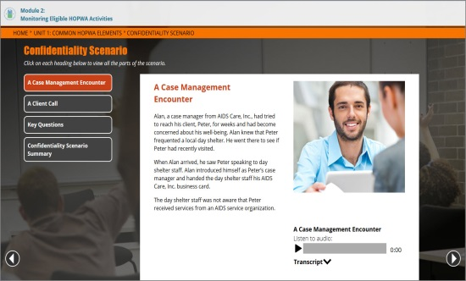 | 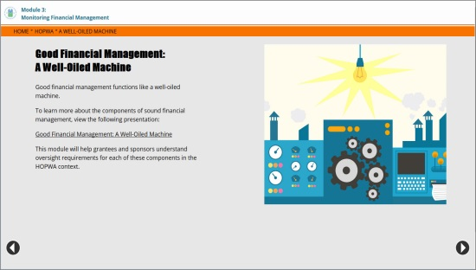
Access the HOPWA Oversight Training.
Note: You need a HUD Exchange Learn Account to register for this training. Create an account.

