Data Quality Corrective Action Form

The Data Quality Agency Error Form was created by KHC and is utilized by KYHMIS participating agencies. This form is required to assist agencies with defining errors that may be present upon submission of the Data Quality report. As mentioned in the data quality reporting training video, if a threshold error is present, either correction or an explanation of the error must be identified. In addition, a corrective action should be listed for steps taken to remove the error from HMIS. In addition, the Data Quality Error Form will allow the Data and Reporting Team to understand which clients are presenting with errors along with problems the agencies may have finding a solution. This will allow the Data and Reporting team to identify instances in which errors are caused by a system malfunction.

Instructions to complete the Data Quality Agency Error Form
- List your agency name
- List the specific HMIS project name for the report. If you have several reports, complete a separate form for each project presenting errors.
- List the Client ID number. Do not list detailed client information; only list the client ID.
- List the Threshold Question Error (Questions 1 through 5) which can be referenced on the image below.
- List a detailed explanation of the error you are seeing on the report or in HMIS.
- List the corrective action you are taking. This can include contacting the Help Desk, correcting the error yourself or waiting for the error to fall off. Any correction in HMIS will not be shown for 24 hours after HMIS updates. Agency corrections must be made in a timely manner.

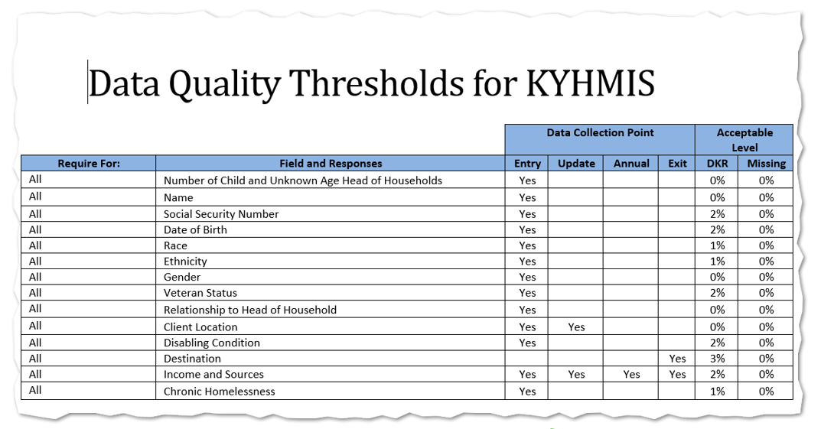
Data Quality Agency Error Form
Agency Name:
Project Name:
Client ID: |  |  |  | Threshold Error:
Explanation:
Corrective Action:

Client ID: |  |  |  | Threshold Error:
Explanation:
Corrective Action:

Client ID: |  |  |  | Threshold Error:
Explanation:
Corrective Action:

Client ID: |  |  |  | Threshold Error:
Explanation:
Corrective Action:

Client ID: |  |  |  | Threshold Error:
Explanation:
Corrective Action:

Client ID: |  |  |  | Threshold Error:
Explanation:
Corrective Action:

Client ID: |  |  |  | Threshold Error:
Explanation:
Corrective Action:

